**Introduction:**

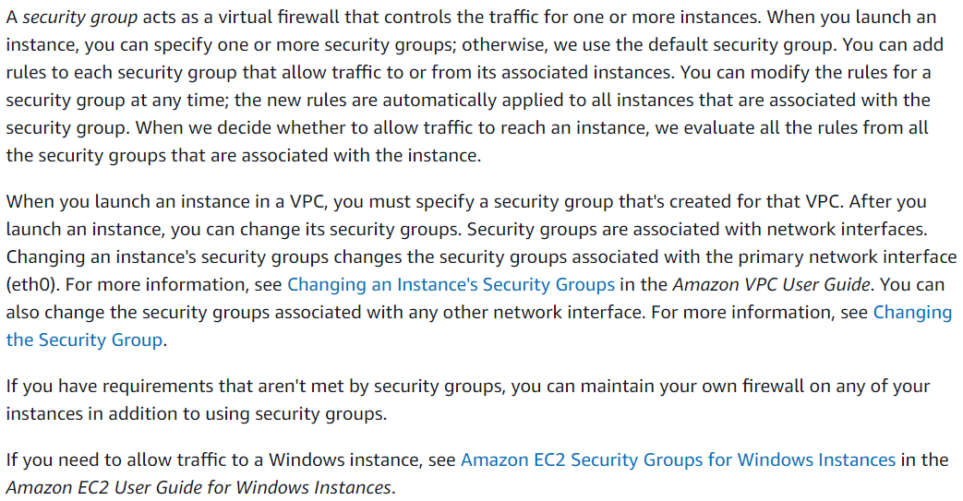

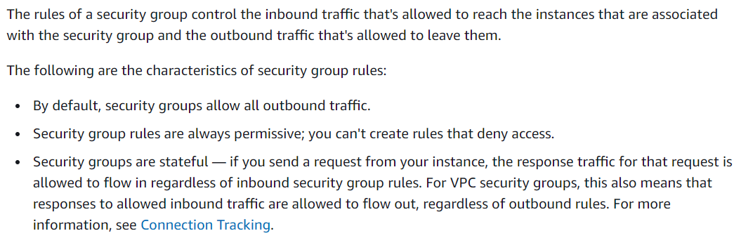

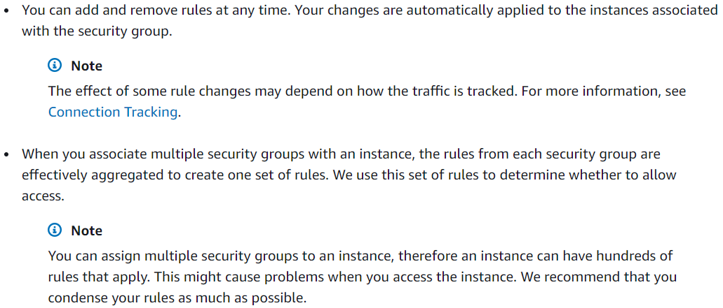

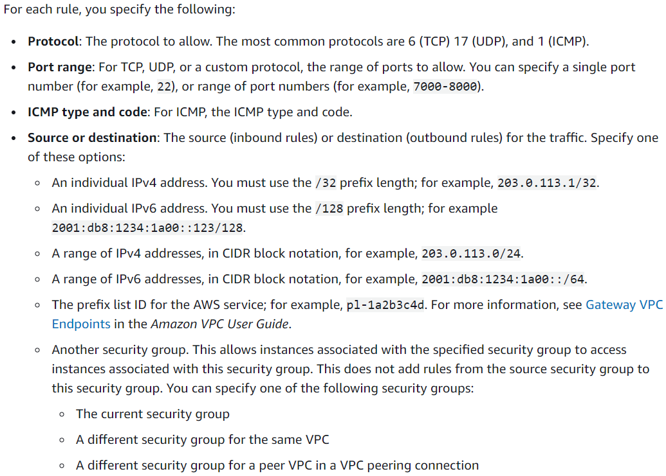

* We can also add CIDR block range of IPs in security group as below.

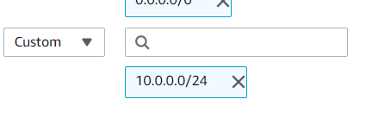

* We can also select “my IP” option as below. So that it will automatically read the public IP and will allow the traffic only from my public IP

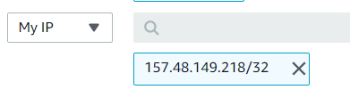

* If we want, we can also add the custom IP from/to which the traffic needs to be sent or received. but we should add “/32” at the end to declare that it is a single IP address we are allowing the traffic.
* AWS won’t accept if we don’t give “/32” there.

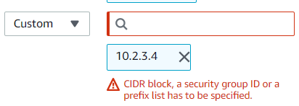

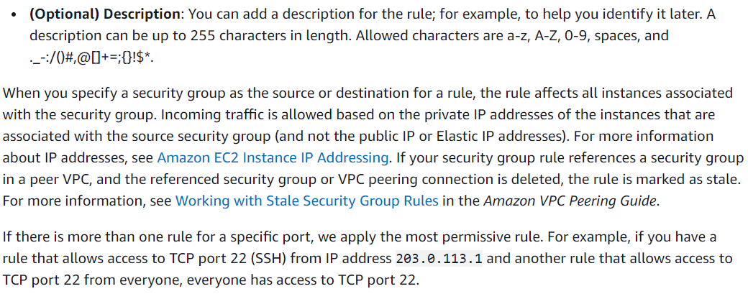

**Default security group:**

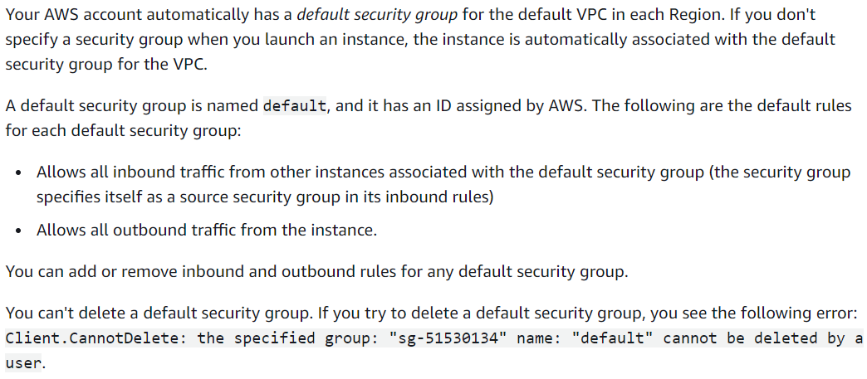

**Custom security group:**

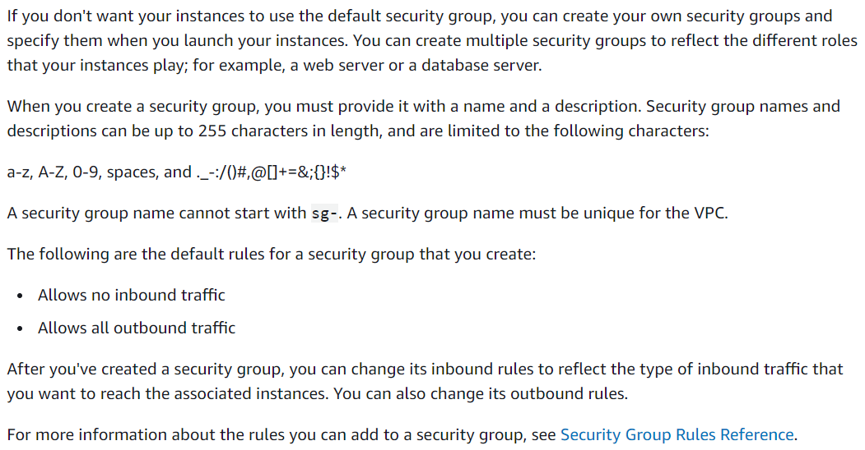

**Deleting a security group:**

